Project: Data Visualization in Python

Startup Growth & Funding Trends

1. Introduction and Objective
This project visualizes the provided startup dataset using Python's Matplotlib library. The objective is to explore key patterns and relationships (e.g., revenue trends, distribution of categories, correlations between users and revenue) and present the findings with at least five different visualization types.
- Dataset: Startup Growth & Funding Trends .
- Source: Kaggle.
- Description of data: The dataset “Startup Growth and Funding Trends” contains 500 rows and 12 columns with details about various startups, such as their industry, funding amount, valuation, revenue, number of employees, and region. It is used to analyze how factors like company size and industry type influence startup funding and growth trends.
- Domain: Business / Finance.

2. Column Description
• Startup Name: Name or identifier of the startup.
• Industry: Business sector or domain the startup operates in.
• Funding Rounds: Number of funding rounds completed by the startup.
• Funding Amount (M USD): Total investment raised in million US dollars.
• Valuation (M USD): Current market valuation of the startup in million US dollars.
• Revenue (M USD): Annual revenue generated by the startup in million US dollars.
• Employees: Total number of employees working in the startup.
• Market Share (%): Percentage of the market controlled by the startup.
• Profitable: Indicates whether the startup is currently profitable (Yes/No or 1/0).
• Year Founded: The year in which the startup was established.
• Region: Geographic region or continent of the startup’s headquarters.
• Exit Status: Current status of the startup (e.g., Private, IPO, Acquired, Shutdown).

3. Python Codes
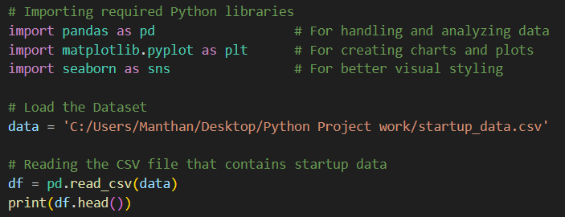

4. Data Visualization

● PIE CHART
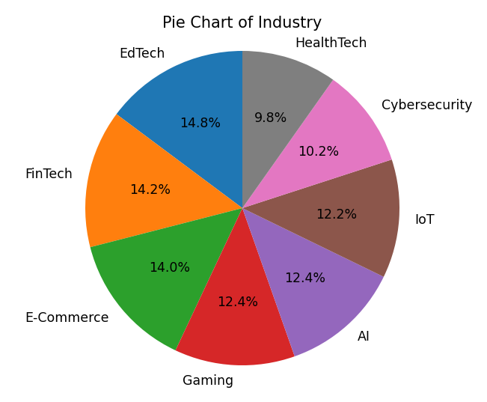
Interpretation:
The pie chart shows the industry distribution of companies, with EdTech being the largest sector at 14.8%, followed closely by FinTech at 14.2% and E-Commerce at 14%. AI and Gaming both represent 12.4% of companies, while IoT accounts for 12.2%. Cybersecurity makes up 10.2% and HealthTech is the smallest sector at 9.8%.

CODE: 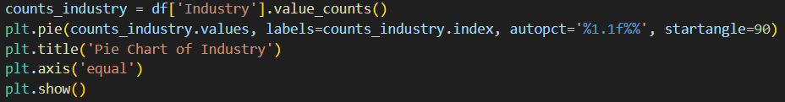

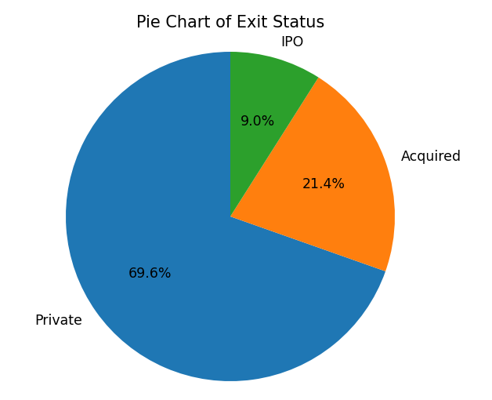
Interpretation:
The pie chart shows company exit status, with the vast majority (69.6%) remaining private, 21.4% having been acquired, and only 9.0% achieving IPO status.

CODE:
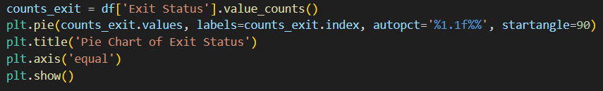

● BAR CHART

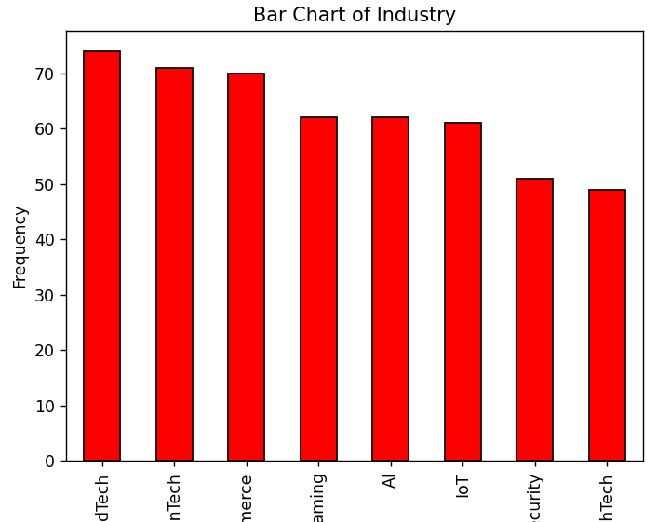
Interpretation:
The bar chart shows industry frequency, with EdTech and FinTech having the highest company counts. E-Commerce, Gaming, AI, and IoT show moderate representation. Cybersecurity and HealthTech have the lowest frequencies among the sectors.

CODE:
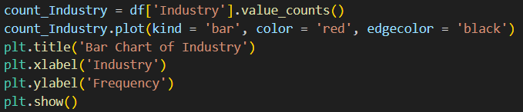

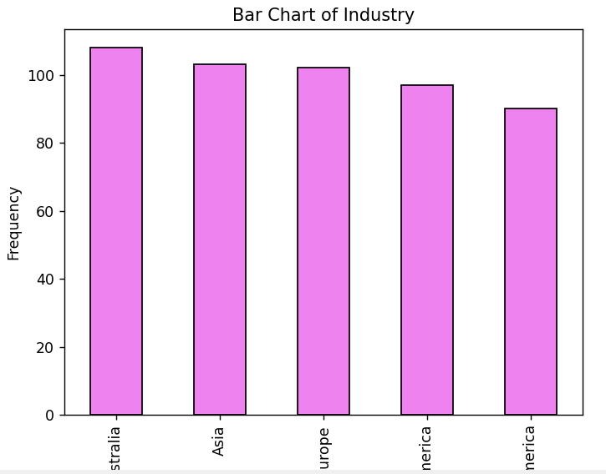
Interpretation:
The bar chart shows regional distribution, with Australia having the highest company frequency. Asia and Europe show similar moderate representation. Both North and South America have the lowest frequencies among the regions.

CODE:
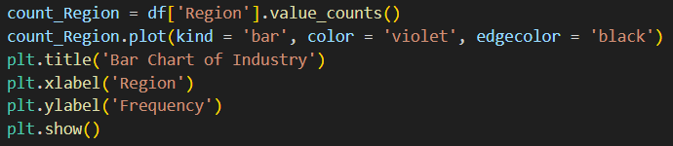

● LINE CHART

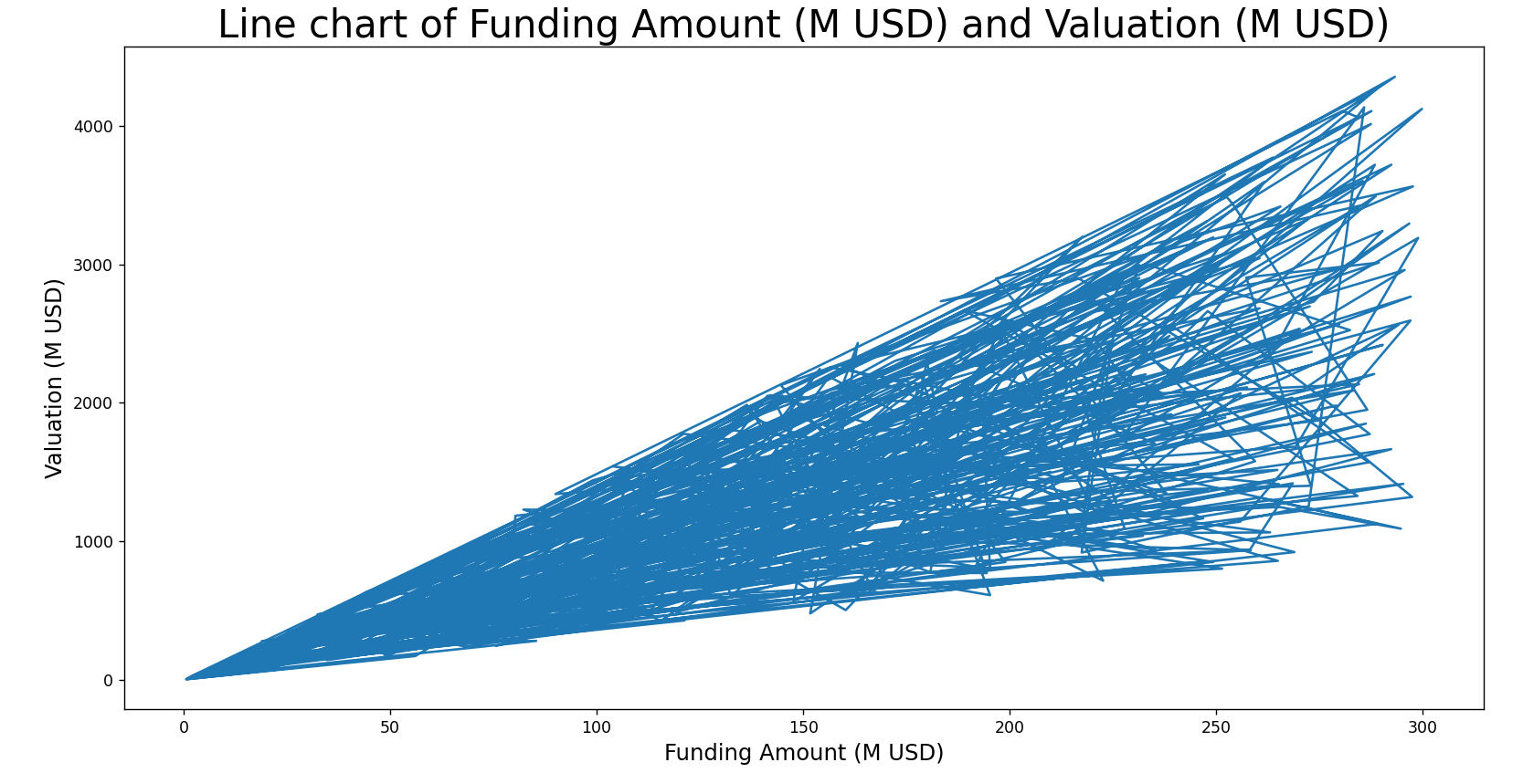
Interpretation:
The line chart shows a clear upward trend, indicating that company valuation increases steadily as funding amounts rise from $0 to $300 million.

CODE:
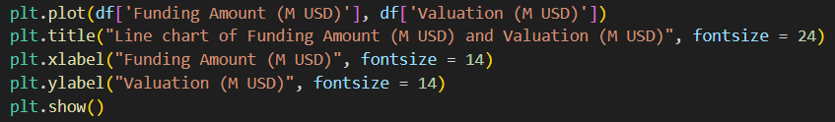

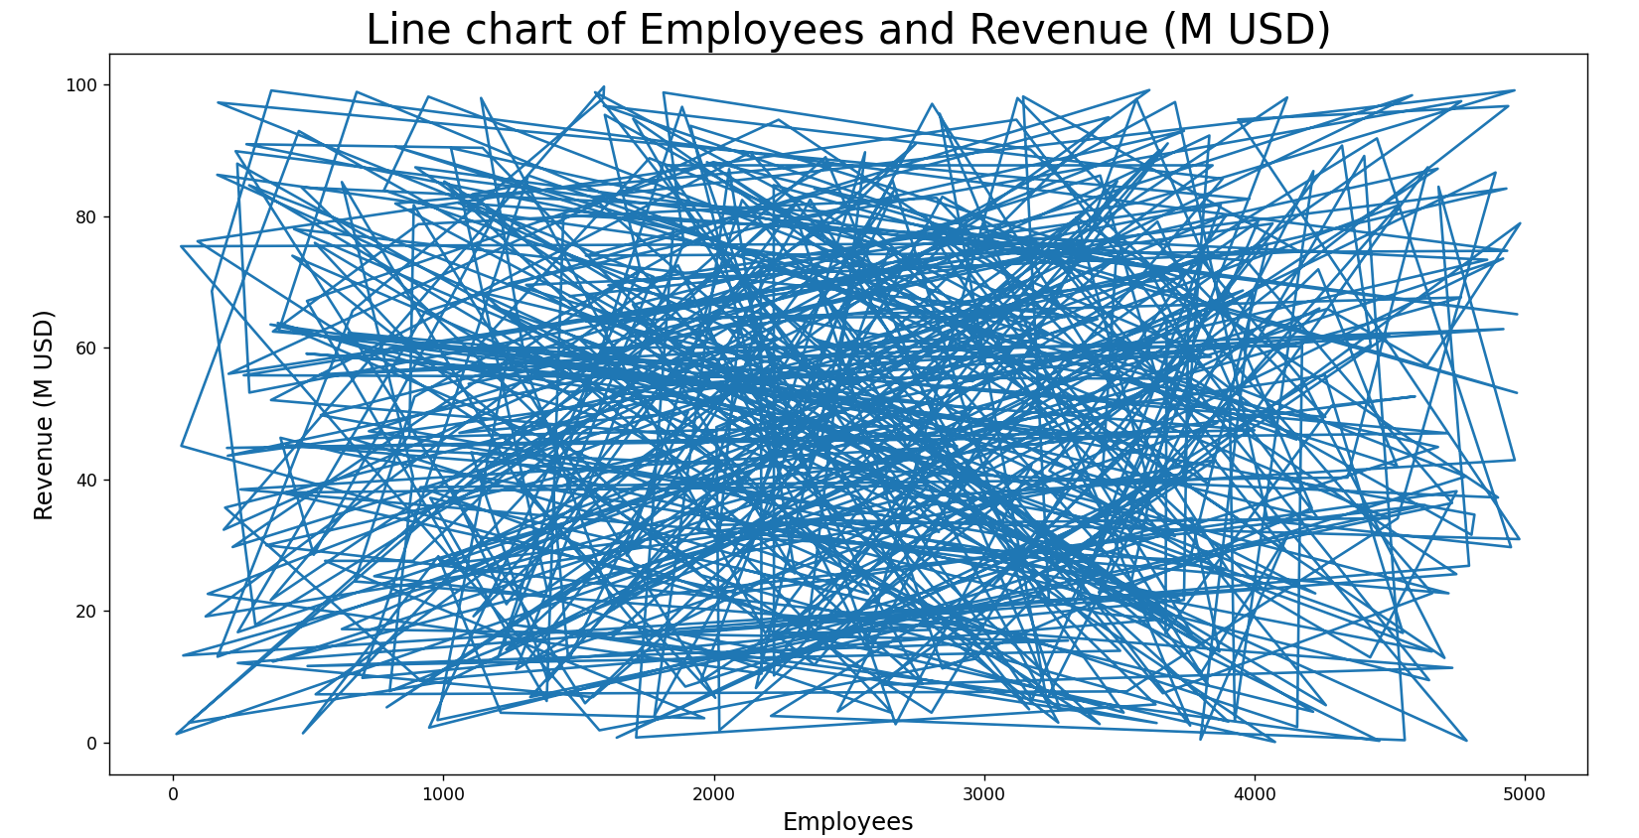
Interpretation:
The line chart shows a positive relationship between employee count and revenue. Companies with more employees tend to generate higher revenue, with revenue increasing as employee numbers grow from 0 to 5000.

CODE:
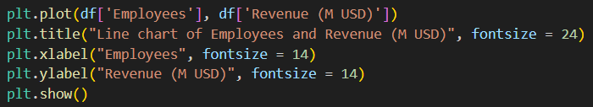

● HISTOGRAM

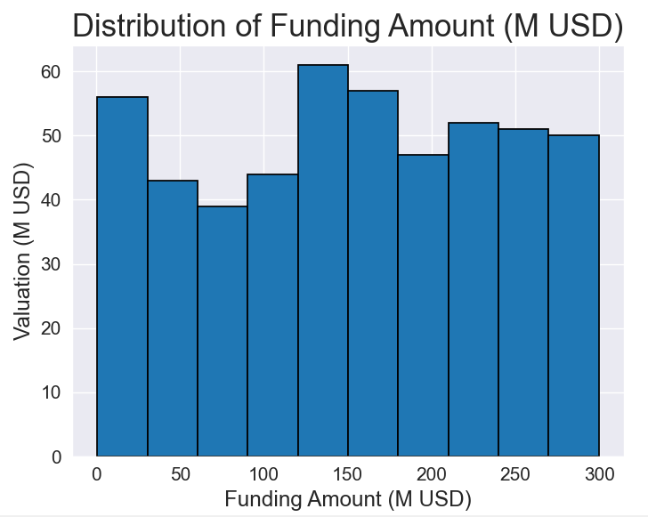
Interpretation:
The histogram shows that valuations are fairly distributed across funding amounts, with the highest valuations occurring around 150 million USD. Overall, there is no clear trend, suggesting that higher funding does not necessarily result in higher valuations.

CODE:
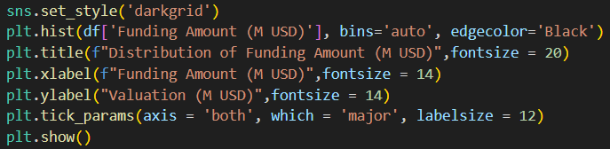

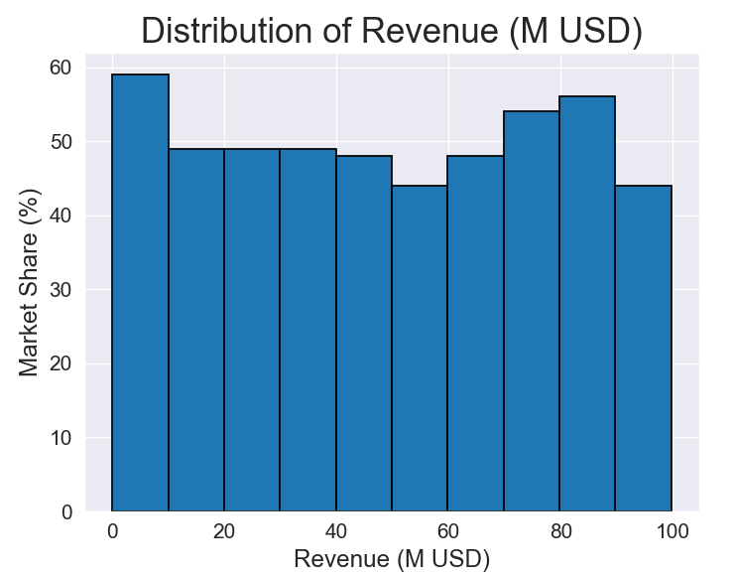
Interpretation:
The histogram shows that market share is fairly balanced across different revenue levels, with slightly higher market share at lower revenues around 0–10 million USD. Overall, revenue does not show a strong influence on market share distribution.
CODE:
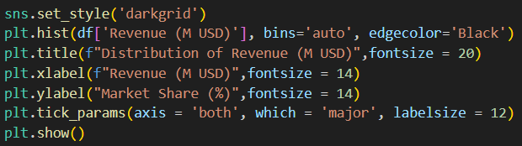

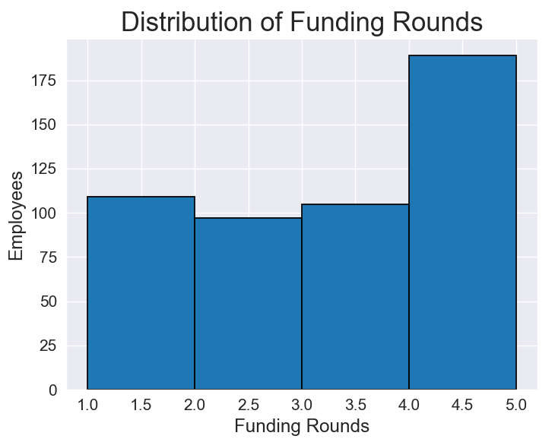
Interpretation:
The histogram shows that companies with around five funding rounds have the highest number of employees, while those with fewer rounds have relatively smaller workforces. This suggests that as companies go through more funding rounds, they tend to expand their employee base.

CODE:
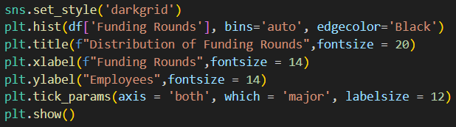

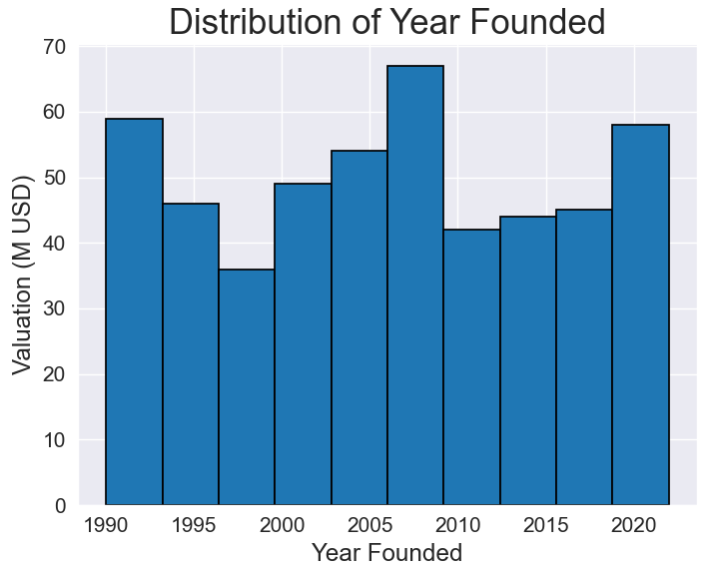
Interpretation:
The histogram shows that companies founded around 2005 have the highest valuations, while those founded in the late 1990s and mid-2010s have lower valuations. Overall, valuations fluctuate across years without a consistent upward or downward trend.
CODE:
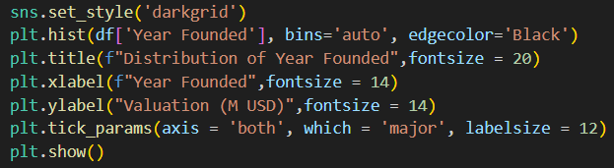

● SCATTER PLOT

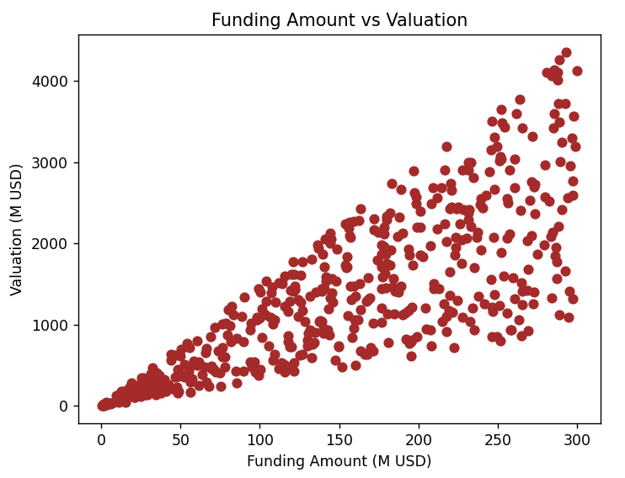
Interpretation:
The scatter plot shows a strong positive correlation between funding amount and valuation. As funding amounts increase from $0 to $300 million, company valuations show a clear upward trend from $0 to $4000 million.

CODE:
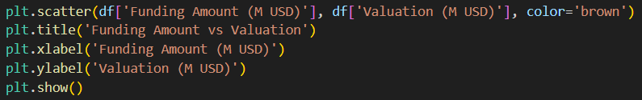

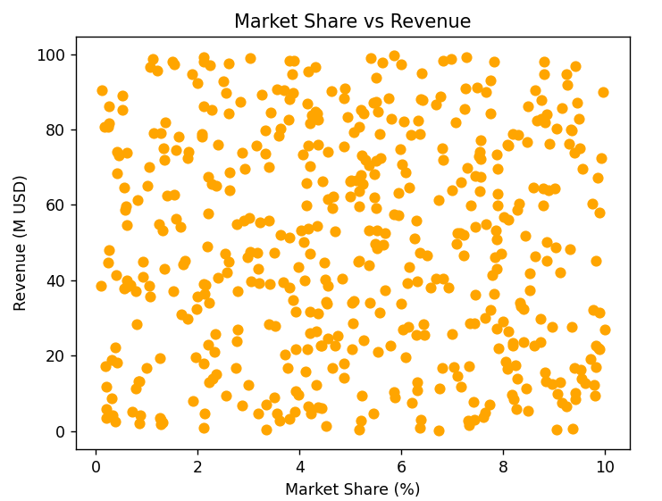
Interpretation:
The scatter plot shows a weak positive relationship between market share and revenue. Companies with higher market share percentages tend to have slightly higher revenue, but the relationship is not strong and shows considerable variation.

CODE:
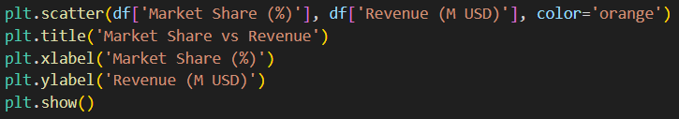

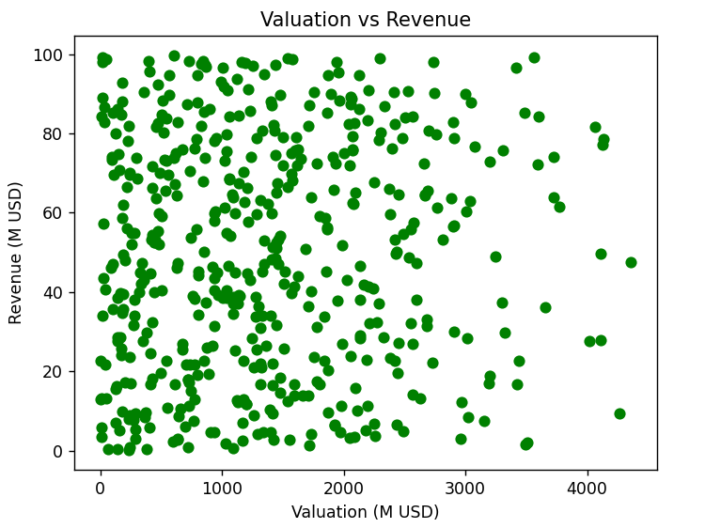
Interpretation:
The scatter plot shows a positive relationship between valuation and revenue. Companies with higher valuations tend to generate higher revenue, though there is considerable variation in the relationship.

CODE:
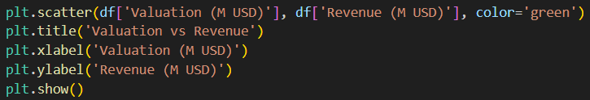

5. Conclusion
This project successfully demonstrates how Python can be effectively used for data visualization to explore and analyze startup growth and funding trends. By utilizing libraries such as Matplotlib, key insights were derived regarding industry distribution, regional presence, funding patterns, and the relationships between valuation, revenue, and employee count. The visualizations clearly show that sectors like EdTech and FinTech dominate the startup landscape, while factors such as higher funding and larger employee bases are generally associated with greater valuation and revenue. Overall, this project highlights the power of data visualization in simplifying complex datasets, uncovering meaningful patterns, and supporting data-driven business decisions.

